Website specifications
The main objective of my website is to promote the Lamborghini brand and show that it is a luxurious automative brand by showcasing its high-performance cars and delivering an immersive digital experience that displays the innovation, craftsmanship and exclusivity. The website aims to increase business visibility, finding people who are likely to buy, providing detailed information on the vehicles and increasing customer loyalty for existing customers.
The target audience includes high income earners that are usually around the age of 30-60 such as entrepreneurs and celebrities etc, who have strong interest in luxury sports cars, as well as young automative enthusiast. The audience is mostly global but targeting more the likes of Europe American China and the likes as they are more into luxury and tech whilst also being more advanced.
The type of website that I will be creating will be a mixture of a corporate/brand website and product showcase website. This will allow users to learn about Lamborghini the values they hold and the heritage as well and will also be able to see the different luxury products that they offer.
Website pages should be intuitive and accessible while embodying Lamborghini's brand of luxury. My website utilizes a top down approach. It starts with general categories and works its way into more detailed sub pages. The main categories on my website will be Models, Heritage, and Brand. Models is then separated into Current Models and Limited Series. This allows users to look at Lamborghini's current production cars as well as its high performance, luxury editions that are unique to this brand. Heritage showcases the brand's history, development, and background. Lastly, Brand is connected to two sub pages, about and news. About gives users official and company information. News updates users on what's new and going on with the brand.

Site Map (Navigation Structure)
Home
- Models
  - Current Models
  - Limited Series
- Heritage
- Brand
  - About
  - News
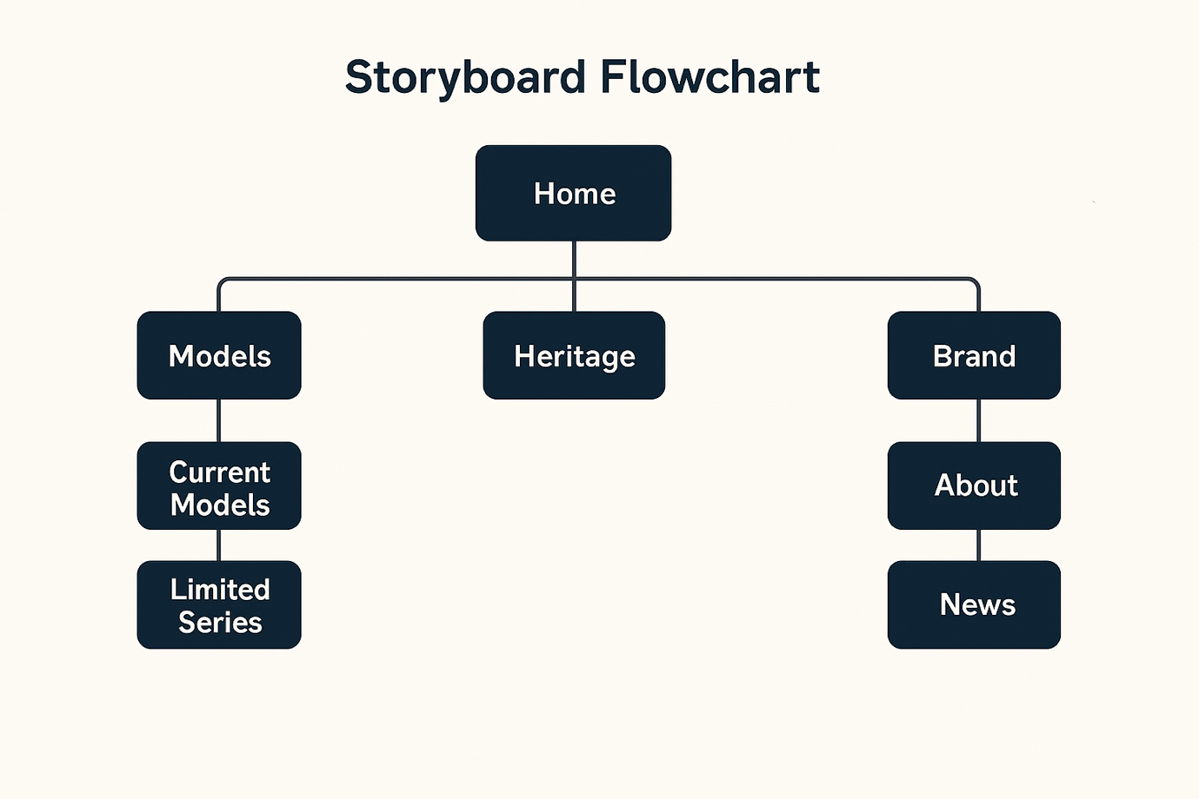

Technical Brief
Visual Studio Code will be the software used to code the website. It is a code editor, not an entire IDE, so it is lightweight but still offers helpful extensions for HTML, CSS, and JavaScript. The scale of this website doesn't require anything more robust. W3Schools will be used as a reference website to help understand how to code certain aspects of the site. This includes responsiveness, navigation, and other helpful tips on modern HTML/CSS techniques. The following technologies will be used to complete this website:
• HTML - To code the content of the website.
• CSS - To style the website and make it responsive.
• JavaScript - To add some interactivity to the website. Websites such as Canva will be used to create/edit images/icons as needed. I want this website to look good but not have large files sitting on the site. Assets such as Google Fonts may be used.

